Food production shocks across land and sea
Supplementary information
Richard S. Cottrell, Kirsty Nash, Benjamin S. Halpern, Tomas A. Remenyi,
Stuart P. Corney, Aysha Fleming, Elizabeth A. Fulton, Sara Hornborg, Alexandra Johne, Reg A. Watson, Julia L. Blanchard

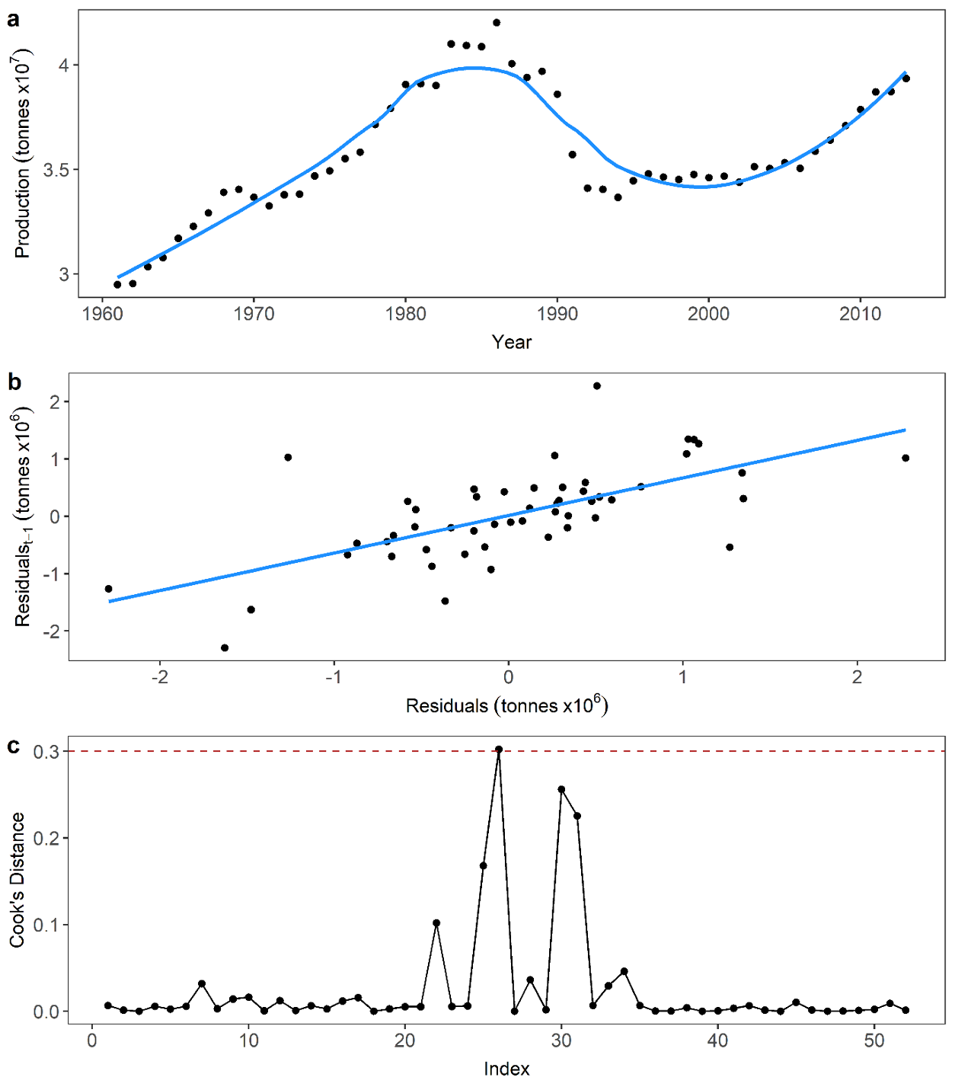
Figure S1 - Statistical shock detection method. a. Local polynomial regression (LOESS) model fitted to food production time-series b. Regression of model residuals against lag-1 residuals c. Production shock in 1991 identified as outlier from regression in b using Cook’s Distance measures
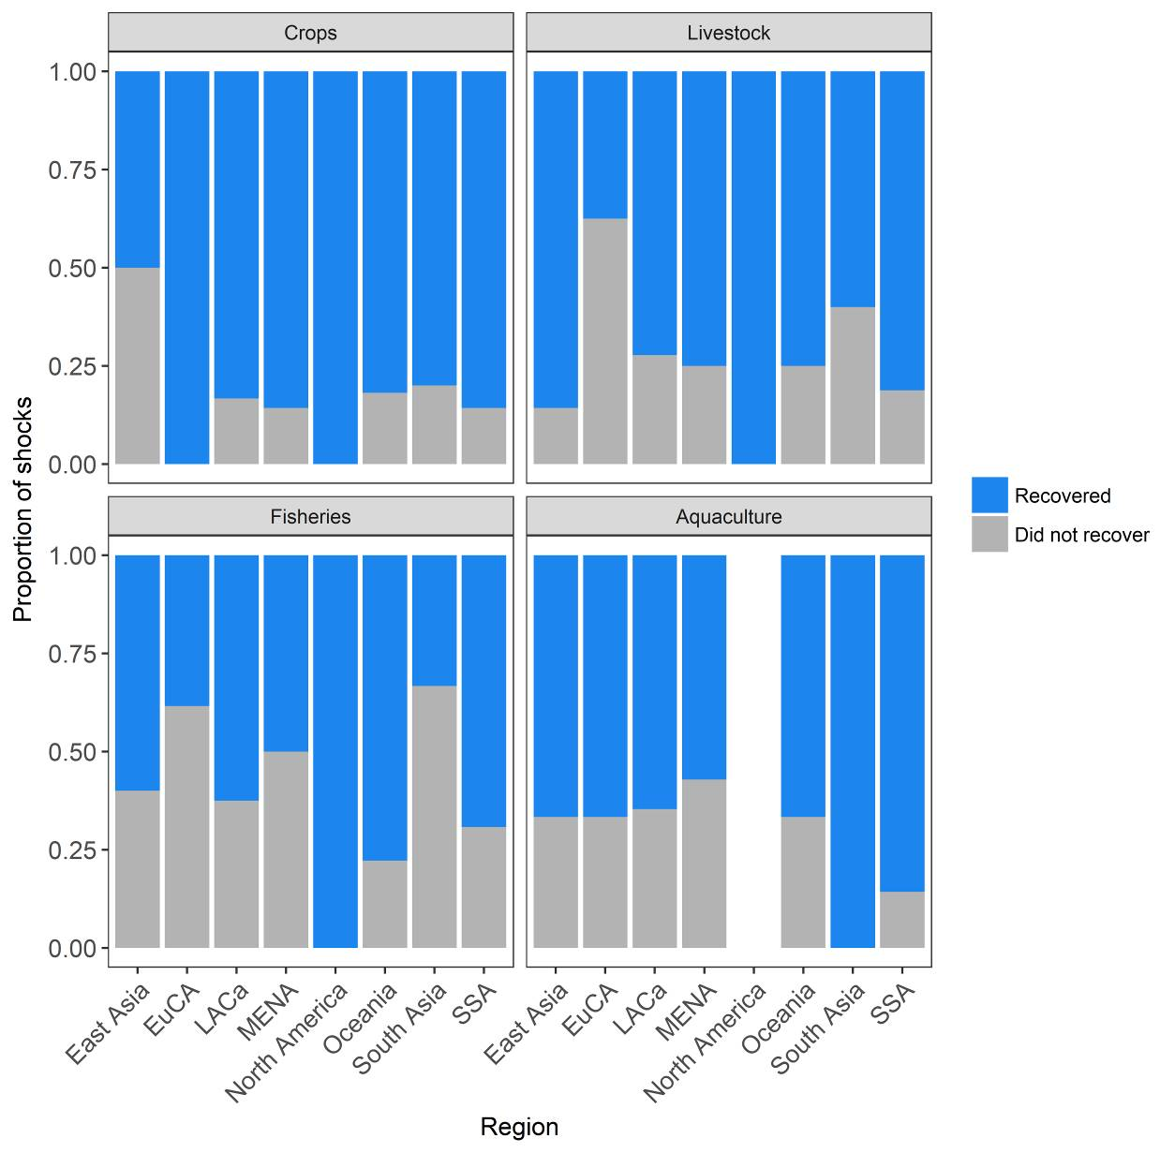
Figure S2 – Proportion of shocks recovered or not during study period in crops, livestock, fisheries and aquaculture sectors across geographic region.

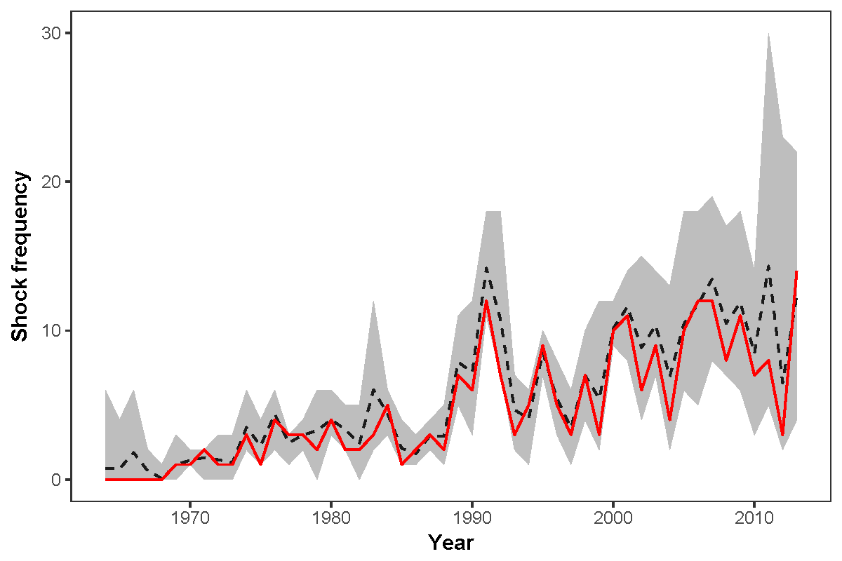
Figure S3 – Shock frequency through time summed across all sectors for a range of parameter combinations. Light grey confidence interval represents range of plausible shock frequencies dependent on span, baseline and average type used in shock detection. Dashed black line is mean of the confidence interval frequencies. Solid red line represents parameter combination that minimizes the sum of squared residuals with the confidence interval mean (parameters selected for this analysis).

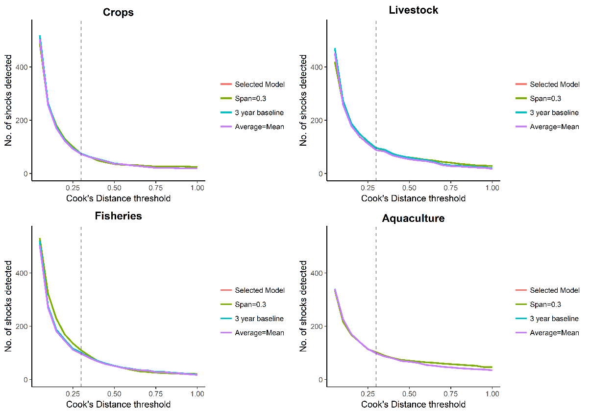
Figure S4– Comparisons of number of shocks detected in crop, livestock, fisheries and aquaculture time series with incremental changes to Cook’s distance values. Lines represent either the combination of model parameters used in this study (‘Selected Model’, LOESS span = 0.6, production baseline = 7 years and average type used = median), or repeated with changes to model span, production baseline or average type. Vertical dashed line represents the Cook’s distance value of 0.3 used in this study

Table S1 – Proportion of imposed shocks detected in simulated time series for different time series standard deviations and shock size combinations.
 |  | Standard deviation
 |  | 0.1 | 0.2 | 0.3 | 0.4 | 0.5 | 0.6 | 0.7 | 0.8 | 0.9 | 1
Magnitude | 0 | 0.003 | 0.001 | 0.001 | 0.001 | 0.003 | 0.001 | 0.002 | 0.001 | 0.001 | 0.003
Magnitude | 0.5 | 0.82 | 0.159 | 0.043 | 0.023 | 0.018 | 0.012 | 0.006 | 0.006 | 0.006 | 0.006
Magnitude | 1 | 1 | 0.805 | 0.345 | 0.161 | 0.061 | 0.036 | 0.018 | 0.017 | 0.008 | 0.01
Magnitude | 1.5 | 1 | 0.995 | 0.786 | 0.459 | 0.246 | 0.122 | 0.089 | 0.052 | 0.035 | 0.026
Magnitude | 2 | 1 | 1 | 0.982 | 0.81 | 0.526 | 0.352 | 0.22 | 0.133 | 0.082 | 0.065
Magnitude | 2.5 | 1 | 1 | 0.997 | 0.97 | 0.781 | 0.603 | 0.408 | 0.273 | 0.177 | 0.131
Magnitude | 3 | 1 | 1 | 1 | 0.994 | 0.954 | 0.813 | 0.651 | 0.469 | 0.301 | 0.22
Magnitude | 3.5 | 1 | 1 | 1 | 1 | 0.99 | 0.934 | 0.813 | 0.666 | 0.506 | 0.41
Magnitude | 4 | 1 | 1 | 1 | 1 | 1 | 0.973 | 0.911 | 0.802 | 0.652 | 0.565
Magnitude | 4.5 | 1 | 1 | 1 | 1 | 1 | 0.995 | 0.974 | 0.906 | 0.824 | 0.668
Magnitude | 5 | 1 | 1 | 1 | 1 | 1 | 1 | 0.99 | 0.957 | 0.902 | 0.821
Magnitude | 5.5 | 1 | 1 | 1 | 1 | 1 | 1 | 0.997 | 0.984 | 0.952 | 0.878
Magnitude | 6 | 1 | 1 | 1 | 1 | 1 | 1 | 0.999 | 0.995 | 0.976 | 0.942

Drivers of shocks
Table S2 – Identified causes for production shocks across all sectors. Asterisks indicate possible drivers for shocks of an unknown cause based on events occurring in country at the shock point. We highlight shocks that did not recover by the end of the time series (2013) by ^{NR} adjacent to the number of years between the shock point and 2013.
See “Supplementary Information – Table S2.xlsx” for table. References for shock drivers contained in excel file and listed below.
References
1. FAO. FAO/WFP Crop and food supply assessment mission to Afghanistan. Global Information and Early Warning Systems on Food and Agriculture World Food Programme. (2002).
2. FAO. Nutrition Country Profile - Republic of Albania. Food and Agricultural Organisation of the United Nations, Rome. (2005).
3. IICA. Agriculture in Antigua and Barbuda 1991-1995 and beyond. Working Document. Socioeconomic policy and trade programme. Inter-American Institute for Cooperation on Agriculture. (1997).
4. Australian Bureau of Statistics. Feature article: 2006 Drought. 1301.0 - Year Book Australia, 2008 http://www.abs.gov.au/ausstats/abs@.nsf/a9ca4374ed (2008). Available at: http://www.abs.gov.au/ausstats/abs@.nsf/a9ca4374ed453c6bca2570dd007ce0a4/ccc8ead2792bc3c7ca2573d200106bde!OpenDocument.
5. Australian Bureau of Meterology. Short-term relief but long-term drought persists. Reports and Summaries http://www.bom.gov.au/climate/drought/archive/2007 (2007). Available at: http://www.bom.gov.au/climate/drought/archive/20070604.shtml.
6. FAO. Bahrain Irrigation in the Middle East region in figures – AQUASTAT Survey 2008. (2008).
7. Hamilton, J. Historical Oil Shocks Working Paper 16790. NBER Working Paper Series, National Bureau of Research, Massachusetts. (2011).
8. OCHA. Bhutan - Floods and Landslides OCHA Situation Report No. 2. ReliefWeb - United Nations Office for Coordination of Humanitarian Affairs https://reliefweb.int/report/bhutan/bhutan-floods- (2000).
9. OCHA. India: Floods Appeal No. 19/2000 Situation Report No. 3. International Federation of Red Cross and Red Crescent Studies. ReliefWeb - United Nations Office for Coordination of Humanitarian Affairs https://reliefweb.int/report/india/india-floods-ap (2000).
10. Niragira, S. et al. Options and Impact of Crop Production Specialization on Small-Scale Farms in the Noth of Burundi. in 4th International conference of the African Association of Agircultural Economists 1–26 (2013).
11. Fambon, S. et al. Slow Progress in Growth and Poverty Reduction in Cameroon. Growth and Poverty in Sub-Saharan Africa 293 (2016).
12. Sunderlin, W. D. et al. Economic crisis, small-scale agriculture, and forest cover change in southern Cameroon. Environ. Conserv. 27, 284–290 (2000).
13. ECLAC. The Impact of Hurricane Ivan in the Cayman Islands Part I. (2004).
14. OECD. Review of Agricultural Policies: Chile. (2008). doi:http://dx.doi.org/10.1787/9789264042247-en
15. Mesa-Lago, C. The Cuban Economy in 2006-2007. in ASCE Association for the Study of the Cuban Economy (2007).
16. Noland, M. Famine and Reform in North Korea. Asian Econ. Pap. 3, 1–40 (2004).
17. Akitoby, B. & Cinyabuguma, M. Sources of growth in the Democratic Republic of the Congo: a cointegration approach. International Monetary Fund. IMF Work. Pap. (2004).
18. FAO. Special Report: Crop and food supply in Kinshasa and the provinces of Bas-Congo and Bandundu of the Deomcratic Republic of the Congo. FAO Global Information and Early Warning System on Food and Agriculture. Food and Agricultural Organization of the UN, Ro. (2000).
19. Mohan, P. The economic impact of hurricanes on bananas: A case study of Dominica using synthetic control methods. Food Policy 68, 21–30 (2017).
20. World Bank. Climate Change Aspects in Agriculture Dominican Republic Country Note. (2008).
21. Bayer, A. M. et al. The 1997–1998 El Niño as an unforgettable phenomenon in northern Peru: a qualitative study. Disasters 38, 351 (2014).
22. Yaffa, S. Loss and damage from drought in the North Bank Region of The Gambia. Loss and Damage in Vulnerable Countries Initiative, case study report. Bonn: United Nations University Institute for Environment and Human Security. (2013).
23. FAO. The World Banana Economy, 1970-1984: Structure, Performance, and Prospects. Rome: Food and Agriculture Organization of the United Nations. (1986).
24. CRED. EM-DAT: The Emergency Events Database. D. Guha-Sapir,Université catholique de Louvain (UCL) www.emdat.be (2009). Available at: www.emdat.be. (Accessed: 9th December 2017)
25. Lal, B., Das, H. P., Samui, R. P. & Kashyapi, A. Impact of Drought on Kharif Crops in Southern India during 2002 as Compared with Kharif 2003. Water Energy Abstr. 14, 14–15 (2004).
26. USDA. USDA Foreign Agricultural Service. Iran: Crop Progress Report. FAS - Office of Global Analysis. (2009).
27. USDA Foreign Agricultural Service. IRAQ: Drought & Irrigation Shortages Decimate Wheat Harvest in 2009/10. Commodity Intelligence report. United States Department of Agriculture. Accessed at:https://ipad.fas.usda.gov/highlights/2 (2009).
28. Oakes, R., Milan, A. & J, C. Kiribati: CLimate change and migration - Relationships between household vulnerability, human mobility and climate change. Report No. 20. Bonn: United Nations University Institute for Environment and Human Security (UNU-EHS). (2016).
29. FAO WFP. Crop and food supply assessment mission to Liberia Special Report. FAO global Information and Early Warning System on Food and Agriculture World Food Programme. Food and Agricultural Organization of the United Nations. Accessed at: http://www.fao.org/docrep/004/x9208e/ (2000).
30. FAO WFP. Special Report: Crop and Food Security Assessment Mission to Madagascar. http://www.fao.org/docrep/018/aq115e/aq115e.pdf (2013).
31. Makoka, D. The impact of drought on household vulnerability: The case of rural Malawi. MPRA Paper No. 15399. University of Bonn, Centre for Development Research (ZEF). (2008).
32. Kimenyi, M. et al. The Impact of Conflict and Political Instability on Agricultural Investments in Mali and Nigeria. Afrca Growth Initiative. Working Paper 17. (2014).
33. Shivute, O. Namibia: Drought crisis looms, Crops wither, farmers abandon cattle posts. AllAfrica http://allafrica.com/stories/199803170094.html (1998).
34. FAO. Nauru and FAO Partnering to improve food security and income-earning opportunities. http://www.fao.org/3/a-av263e.pdf (2015).
35. Crocombe, M. et al. Polynesia in Review: Issues and Events, 1 July 1989 to 30 June 1990. Contemp. Pac. 3, 191–211 (1991).
36. European Drought Centre. Drought of 1975-1976. Central and Northern Europe. Major Drought Events http://www.geo.uio.no/edc/droughtdb/edr/DroughtEve (2013).
37. FAO WFP. Special Report: FAO WFP Crop and food supply assessment mission to Pakistan. http://www.fao.org/docrep/004/Y1260e/Y1260e00.htm (2001).
38. IFRC. Paraguay Drought DREF operation no. MDRPY007 Glide No. DR-2009-000104-PRY Update no. 1. (2009).
39. Velazco, J. Agricultural Production in Peru (1950-1995): Sources of Growth. (2001).
40. Berke, P. & Wenger, D. Linking Hurricane Disaster Recovery to Sustainable Development Strategies in Saint Kitts and Nevis, West Indies. (1991).
41. Elhadj, E. Camels don’t fly, deserts don’t bloom: an assessment of Saudi Arabia’s experiment in desert agriculture. Occasional Paper No 48 Water Issues Study Group School of Oriental and African Studies (SOAS)/King’s College London University of London. (2004).
42. Jeilani, O. The impact of civil war on crop production in Somalia. in ICAS VII Seventh International Conference on Agricultural Statistics. Rome 315–317 (2016). doi:10.1481/icasVII.2016.a06d
43. Al-Khalidi, S. & El Dahan, M. War-ravaged Syria may face worst wheat harvest in 40 years. Reuters https://www.reuters.com/article/us-syria-wheat-cro (2014).
44. Tran, P. La Niña blow to crops. IRIN http://www.irinnews.org/report/90624/timor-leste-l (2010).
45. OCHA. 2013 Rainy Season Overview West and Central Africa. United Nations Office for Coordination Humanitarian Affairs. (2013).
46. Wreford, A. & Neil Adger, W. Adaptation in agriculture: Historic effects of heat waves and droughts on UK agriculture. Int. J. Agric. Sustain. 8, 278–289 (2010).
47. OCHA. PWS&D responds to drought in Tanzania. ReliefWeb - United Nations Office for Coordination of Humanitarian Affairs https://reliefweb.int/report/united-republic-tanza (2003).
48. Rojas, O., Li, Y. & Cumani, R. Understanding the drought impact of El Niño on the global agricultural areas: An assessment using FAO’s Agricultural Stress Index (ASI). (2014).
49. Anon. El Niño intensifies Latin American drought. The Telegraph https://www.telegraph.co.uk/expat/expatnews/661392 (2009).
50. Anon. Huila: Over 300,000 Heads Of Cattle Vaccinated. Agencia Angola Press http://www.angop.ao/angola/en_us/noticias/economia (2006).
51. Mattion, N. et al. Reintroduction of foot-and-mouth disease in Argentina: characterisation of the isolates and development of tools for the control and eradication of the disease. Vaccine 22, 4149–4162 (2004).
52. Keka Israt, A., Matin, I., Rahman, M. & Banu, D. A. Analysis of Drought in Eastern Part of Bangladesh. 20 DAFFODIL Int. Univ. J. Sci. Technol. 7, 20–27 (2012).
53. IICA. Working Paper: Agriculture in Barbados: 1991 -1995 and Beyond. (1997).
54. UNESCAP. Bhutan Country Presentation. in Regional Capacity Development Workshop: Mainstreaming DRR in Sustainable Development Planning. United Nations Economic and Social Comission for Asia and the Pacific http://www.unescap.org/sites/default/files/Bhutan% (2016).
55. Austrian Development Agency. Support to mitigate disaster caused by floods in Bhutan. Projects http://www.entwicklung.at/en/projects/detail-en/pr (2009).
56. Schmitz, A., Moulton, K., Buckwell, A. & Davidova, S. Privatization of agriculture in new market economies: lessons from Bulgaria. 6, (Springer Science & Business Media, 2012).
57. Riera, O. & Swinnen, J. Cuba’s agricultural transition and food security in a global perspective. Appl. Econ. Perspect. Policy 38, 413–448 (2016).
58. Noland, M., Robinson, S. & Wang, T. Famine in North Korea: Causes and Cures. Econ. Dev. Cult. Change 49, 741–767 (2001).
59. FAO. Country Report on the State of Plant Genetic Resources for Food and Agriculture: Dominica. (2008).
60. Anon. Dominican Republic in Crisis. The New York Times https://www.nytimes.com/2003/12/29/opinion/dominic (2003).
61. Anon. Cow Disease Hits Fiji. Solomon Times Online http://www.solomontimes.com/news/cow-disease-hits- (2009).
62. Chloupkova, J. Czech Agricultural Sector: Organisational Structure and its Transformation. The Royal Veterinary and Agricultural University. Food and Resource Economic Institute (2002).
63. Brioudes, A., Warner, J., Hedlefs, R. & Gummow, B. A review of domestic animal diseases within the Pacific Islands region. Acta Trop. 132, 23–38 (2014).
64. Petrick, M. Modernizing Russia’s cattle and dairy Sectors under WTO conditions: Insights from East Germany. Discussion Paper, Leibniz Institute of Agricultural Development in Transition Economic 150, (2014).
65. Cuyler, C. Success and failure of reindeer herding in Greenland. Rangifer Rep. 81–92 (1999).
66. Clegg, P. Revolutionary politics in Grenada - a retrospective. E-International relations http://www.e-info/2013/07/02/revolutionary-poli (2013).
67. Bucayu-laurent, C. & Hollyer, J. R. Some History and Trends of Agriculture on Guam: Data from the U.S. Census of Agriculture and Other Sources, 1920-2007. Agricultural data 01. College of Natural and Applied Sciences. University of Guam. (2016).
68. Lanzsky, I. & Komives, T. Changing agriculture in Eastern Europe : Hungary as an example. Agro Food Ind. Hi Tech 31–33 (1994).
69. FAO. Update on FAO’s activities in relation to the 1997/98 El Niño and La Niña. Newsroom - Food and Agricultural Organisation of the UNited Nations (1998).
70. Schnepf, R. CRS Report for Congress. Iraq Agriculture and Food Supply: Background and Issues. (2004).
71. FAO. The State of Food and Agriculture. No 25 Food and Agricultural Organisation of the United Nations. Rome. (2002).
72. Jansen, H. Rangeland development in Northern Libya. Rangelands 10, 178–182 (1988).
73. Devereux, S. The Malawi famine of 2002. IDS Bull. 33, 70–78 (2002).
74. World Bank Asian Development Bank UN. Maldives Tsunami: Impact and Recovery. Joint Needs Assessment by World Bank-ADB-UN System. (2004).
75. FAO. Mali conflict: Contingency and Response Plan. The Sahel Crisis. (2013).
76. International Bank for Reconstruction and Development. The Current tconomic Situation And Prospects of Mauritania. (1974).
77. Gupte, P. Indian Ocean Nation of Mauritius Struggles Through Economic and Political Crisis. The New York Times https://www.nytimes.com/1979/11/20/archives/indian (1979).
78. Liverman, D. Vulnerability and adaptation to drought in México. Nat. Resour. J. 39, 99–115 (1999).
79. Rao, M. P. et al. Dzuds, droughts, and livestock mortality in Mongolia. Environ. Res. Lett. 10, (2015).
80. Pollard, W. & Christ, N. Caribbean Region: Review of Economic Growth and Development. U . S . International Trade Commission. Investigation Number 332 - 496. (2008).
81. CARDI. Montserrat: Country Profile. Carribbean Agricultural Research and Development Institute http://www.cardi.org/country-offices/montserrate/ (2011).
82. Prévost, G. The" Contra" War in Nicaragua. J. Confl. Stud. 7, (1987).
83. Swinton, S. M. Drought survival tactics of subsistence farmers in Niger. Hum. Ecol. 16, 123–144 (1988).
84. Agbola, B. S., Ajayi, O., Taiwo, O. J. & Wahab, B. W. The August 2011 flood in Ibadan, Nigeria: Anthropogenic causes and consequences. Int. J. Disaster Risk Sci. 3, 207–217 (2012).
85. Forbord, M., Bjørkhaug, H. & Burton, R. J. F. Drivers of change in Norwegian agricultural land control and the emergence of rental farming. J. Rural Stud. 33, 9–19 (2014).
86. Sutmoller, P. & Olascoaga, R. C. The successful control and eradication of Foot-and-mouth disease epidemics in South America in 2001. Evid. Tempor. Comm. Foot-and-Mouth Dis. Eur. Parliam. 1–8 (2002).
87. Caribbean Development Bank. St . Kitts and Nevis. Annu. Econ. Rev. 91–102 (2005).
88. OCHA. Tropical Storm Lili Situation Report No. 1. ReliefWeb - United Nations Office for Coordination of Humanitarian Affairs https://reliefweb.int/report/barbados/tropical-sto (2002).
89. Organisation of Eastern Caribbean States. Grenada : Macro-Socio-Economic Assessment of the Damage caused by Hurricane Emily. (2005).
90. Seibert, G. São Tomé and Príncipe 1975-2015: politics and economy in a former plantation colony. Estud. Ibero-Americanos 42, 987 (2016).
91. Paton, N. I. et al. Outbreak of Nipah-virus infection among abattoir workers in Singapore. Lancet 354, 1253–1256 (1999).
92. Majid, N. & McDowell, S. Hidden dimensions of the Somalia famine. Glob. Food Sec. 1, 36–42 (2012).
93. OCHA. FAO/WFP crop and food supply assessment mission to Indonesia. ReliefWeb - United Nations Office for Coordination of Humanitarian Affairs https://reliefweb.int/report/indonesia/faowfp-crop (1998).
94. Garland, A. J. M. A review of the foot-and-mouth disease situation on Turkey during the last decade, including a critical assessment of past national and international control programmes, and with recommendations for future control. Rep. 34th Sess. Eur. Comm. Control Foot-and-Mouth Dis. FAO, Rome, Italy. March. Append. 8, 80–95 (2001).
95. Wilpert, G. in Promised Land: Competing Visions of Agrarian Reform (eds. Rosset, P., Patel, R. & Courville, M.) 249–176 (2006).
96. Chilonda, P. et al. Foot and mouth disease in Zambia: a review of the aetiology and epidemiology and recommendations for possible control. Rev. Sci. Tech. Int. Off. Epizoot. 18, 585–592 (1999).
97. FAO WFP. Special Report: Crop and food supply assessment mission to Zimbabwe. (2002).
98. FAO. Fisheries and Aquaculture Country Profiles. The Islamic Republic of Afghanistan. (2015).
99. Moutopoulos, D., Bradshaw, B. & Pauly, D. Reconstruction of Albania fishery catches by fishing gear. Fish. Cent. Work. Pap. Ser. 12, (2015).
100. Belhabib, D. & Divovich, E. in Fisheries catch reconstructions: West Africa, Part II. Fisheries Centre Research Reports vol.23(3) 23, 115–128 (2015).
101. Ramdeen, R., Zylich, K. & Zeller, D. Reconstruction of Total Marine Fisheries Catches for Anguilla (1950-2010). Fish. catch Reconstr. Islands, Part IV 22, 1–8 (2014).
102. Georges, J., Ramdeen, R., Zylich, K. & Zeller, D. Reconstruction of total marine fisheries catch for Antigua and Barbuda (1950-2010). Work. Pap. Ser. Fish. Centre, Univ. Br. Columbia 17 (2015).
103. Mohammed, E., Lindop, A., Parker, C. & Willoughby, S. Reconstructed fisheries catches of Barbados, 1950-2010. Work. Pap. Ser. Fish. Centre, Univ. Br. Columbia 86, 6–9 (2015).
104. Lescrauwaet, A. K., Fockedey, N., Debergh, H., Vincx, M. & Mees, J. Hundred and eighty years of fleet dynamics in the Belgian sea fisheries. Rev. Fish Biol. Fish. 23, 229–243 (2013).
105. Zeller, D., Graham, R. & Harper, S. in Too Precious to Drill: the Marine Biodiversity of Belize 19, 142–151 (2011).
106. Belbase, K. & Morgan, R. Food security and nutrition monitoring for drought relief management: The case of Botswana. Food Policy 19, 285–300 (1994).
107. Masih, I., Maskey, S., Mussá, F. E. F. & Trambauer, P. A review of droughts on the African continent: A geospatial and long-term perspective. Hydrol. Earth Syst. Sci. 18, 3635–3649 (2014).
108. Kolding, J., van Zwieten, P., Marttin, F. & Poulain, F. FISHERIES IN THE DRYLANDS OF SUB-SAHARAN AFRICA “ Fish come with the Rains ” Building resilience for fisheries-dependent livelihoods to enhance food security and nutrition in the drylands. FAO Fisheries and Aquaculture Circular No.1118. 1118, (2016).
109. Battaglini, E. The Black Sea — A Dramatic Recovery. Environment Matters Annual Review. World Bank. (2008).
110. Keskin, Ç. et al. The Marine Fisheries in Bulgaria’s Exclusive Economic Zone, 1950–2013. Front. Mar. Sci. 4, 1–10 (2017).
111. FAO. Information on Fisheries Management in the Republic of Burundi. (1999).
112. FAO. Central African Republic: farming and families hit by insecurity. Food and Agriculture Organization of the United Nations http://www.fao.org/news/story/en/item/263271/icode (2014).
113. Springer, K. A 400 year old port - with no boats. BBC Travel http://www.bbc.com/travel/story/20151110-preservin (2015).
114. Ramdeen, R., Harper, S. & Zeller, D. Reconstruction of total marine fisheries catches for Dominica (1950-2010). Fish. Catch Reconstr. Islands, Part IV. Fish. Cent. Res. Reports. Sea Around Us Fish. Centre, Univ. Bristish Columbia 22(2), 33–41 (2014).
115. Ram, R., Chand, R. V. & Southgate, P. C. An overview of sea cucumber fishery management in the Fiji islands. Su Ürünleri Derg. 11, 191–205 (2016).
116. Gephart, J. A., Deutsch, L., Pace, M. L., Troell, M. & Seekell, D. A. Shocks to fish production: Identification, trends, and consequences. Glob. Environ. Chang. 42, 24–32 (2017).
117. Beare, D. J. et al. Long-term increases in prevalence of North Sea fishes having southern biogeographic affinities. Mar. Ecol. Prog. Ser. 284, 269–278 (2004).
118. Moutopoulos, D. K. & Stergiou, K. I. Spatial disentangling of Greek commercial fisheries landings by gear between 1928-2007. J. Biol. Res. 18, 265–279 (2012).
119. Mohammed, E. & Lindop, A. Grenada: Reconstructed Fisheries Catches, 1950-2010. Fish. Cent. Res. Reports, Univ. Br. Columbia 86, 6–9 (2006).
120. FAO. National Aquaculture Sector Overview. Hungary. National Aquaculture Sector Overview Fact Sheets. Text by Varadi, L. In: FAO Fisheries and Aquaculture Department [online]. Rome. Updated 1 January 2003. (2003).
121. Piroddi, C. et al. Reconstruction of Italy’s marine fisheries catches (1950-2010). Fish. Cent. Work. Pap. Ser. 22, 1–41 (2014).
122. FAO. Fishery Country Profile. Jamaica - Structure and Characteristics of the Fishing Industry. Food and AGricultural Organization of the United Nations. (2005).
123. Aiken, K., Kong, A., Smikle, S., Appeldoorn, R. & Warner, G. Managing Jamaica’s queen conch resources. Ocean Coast. Manag. 49, 332–341 (2006).
124. Ojuok, J. E., Njiru, M., Ntiba, M. J. & Mavuti, K. M. The effect of overfishing on the life-history strategies of Nile tilapia, Oreochromis niloticus (L.) in the Nyanza Gulf of Lake Victoria, Kenya. Aquat. Ecosyst. Heal. Manag. 10, 443–448 (2007).
125. McClanahan, T. R., Hicks, C. C. & Darling, E. S. Malthusian overfishing and efforts to overcome it on Kenyan coral reefs. Ecol. Appl. 18, 1516–1529 (2008).
126. SPREP Pacific Regional Environment Programme. State of the environment report. Government of the Republic of Kiribati. (2004).
127. Shon, S., Harper, S. & Zeller, D. Reconstruction of Marine Fisheries Catches for the Democratic People’s Republic of Korea (North Korea) from 1950-2010. Fish. Cent. Work. Pap. Ser. Univ. Br. Columbia 20, 1–11 (2010).
128. Mathews, C. P., Kedidi, S., Fita, N. I., Al-Yahya, A. & Al-Rasheed, K. Preliminary assessment of the effects of the 1991 Gulf War on Saudi Arabian prawn stocks. Mar. Pollut. Bull. 27, 251–271 (1993).
129. Pauly, D. & Zeller, D. So long, and thanks for all the fish: The Sea Around Us, 1999-2014 A Fifteen-Year Retrospective. Fisheries Centre, University of British Columbia (2016).
130. FAO NACA SEAFDEC BOBP-IGO. Tsunami Impact on Fisheries and Aquaculture in Malaysia. (2005).
131. Adam, M. Declining Catches of Skipjack in the Indian Ocean – Observations from the Maldives. in Proceedings of the 10th Meeting of the Working Party on Tropical Tuna, Indian Ocean Tuna Commission 1–2 (2010).
132. Doherty, B., Herfaut, J., Manach, F. Le, Harper, S. & Zeller, D. Reconstructing domestic marine fisheries in Mayotte from 1950-2010. Fish. catch Reconstr. West. Indian Ocean. 1950-2010 53–66 (2015).
133. Ramdeen, R., Ponteen, A., Harper, S. & Zeller, D. in Fisheries catch reconstructions: Islands, Part III. Fisheries Centre Research Reports 20(5). Fisheries Centre, University of British Columbia 69–78 (2012).
134. Harper, S., Frotté, L., Bale, S., Booth, S. & Zeller, D. in Fisheries catch reconstructions: Islands, Part I. Fisheries Centre Research Reports 17 (5). Fisheries Centre, University of British Columbia (eds. Zeller, D. & Harper, S.) 67–76 (2009).
135. Clark, M. Are deepwater fisheries sustainable? — the example of orange roughy (Hoplostethus atlanticus) in New Zealand. Fish. Res. 51, 123–135 (2001).
136. Zylich, K., Harper, S., Winkler, N., and Zeller, D. in Fisheries catch reconstructions: Islands, Part III. Fisheries Centre Research Reports 20(5). Fisheries Centre, University of British Columbia (eds. Harper, S. et al.) 77–86 (2012).
137. Lingard, S., Harper, S., Ota, Y. & Zeller, D. in Fisheries catch reconstructions: Islands, Part II. Fisheries Centre Research Reports 19(4). Fisheries Centre, University of British Columbia (eds. Harper, S. & Zeller, D.) 73–84 (2011).
138. Anticamara, J. A. & Go, K. T. B. Spatio-Temporal Declines in Philippine Fisheries and its Implications to Coastal Municipal Fishers’ Catch and Income. Front. Mar. Sci. 3, 1–10 (2016).
139. Bӑnaru, D., Manach, F. Le, Färber, L., Zylich, K. & Pauly, D. From bluefin tuna to gobies: a reconstruction of the fisheries catch statistics in Romania, 1950-2010. Fish. Cent. Work. Pap. Ser. 11 (2015).
140. Mohammed, E., Lindop, A. & Lucia, S. St. Lucia: Reconstructed fisheries catches, 1950 -2010. Fish. Cent. Work. Pap. Ser. Univ. Br. Columbia 53, 1950–2010 (2015).
141. Pena, M., Oxenford, H. A., Parker, C. & Johnson, A. Biology and fishery management of the white sea urchin, Tripneustes ventricosus, in the eastern Caribbean. FAO Fisheries and Aquaculture Circular No 1056 1–43 (2010).
142. Itano, D. G. Small-scale fisheries for bottomfish in American Samoa (1961-1987). SPC Fish. Newsl. #77 28–32 (1996).
143. Martin, J. I. Fisheries in the Seychelles and Fisheries Agreements with the EU. D. Directorate-General for Internal Policies of the Union. Policy Department B: Structural and Cohesian Policies 64 (2011).
144. Doyle, B., Harper, S., Jacquet, J. & Zeller, D. in Fisheries catch reconstructions: Islands, Part III. Fisheries Centre Research Reports 20(5). Fisheries Centre, University of British Columbia [ISSN (eds. Harper, S. et al.) 20, 2080 (2014).
145. Baust, S., Teh, L., Harper, S. & Zeller, D. in Fisheries catch reconstructions in the Western Indian Ocean, 1950-2010 (eds. Le Manach, F. & Pauly, D.) 23(2), 129–150 (2015).
146. De Silva, D. A. M. & Yamao, M. Effects of the tsunami on fisheries and coastal livelihood: A case study of tsunami-ravaged southern Sri Lanka. Disasters 31, 386–404 (2007).
147. Hornby, C., Harper, S., MacDonald, J. & Zeller, D. Reconstruction of Suriname’S Marine Fisheries Catches From 1950-2010. Fish. Cent. Work. Pap. Ser. Univ. Br. Columbia 49, 1–29 (2015).
148. Burkhardt-Holm, P., Peter, A. & Segner, H. Decline of fish catch in switzerland: Project fishnet: A balance between analysis and synthesis. Aquat. Sci. 64, 36–54 (2002).
149. Ulman, A., Saad, A., Zylich, K., Pauly, D. & Zeller, D. in Global Atlas of Marine Fisheries: A Critical Appraisal of Catches and Ecosystem Impacts (eds. Pauly, D. & Zeller, D.) 406 (sland Press, Washington DC, USA., 2017).
150. Jacquet, J. & Zeller, D. in Reconstruction of marine fisheries catches for key countries and regions (1950- 2005) (eds. Zeller, D. & Pauly, D.) 15(2), 49–60 (2007).
151. Ulman, A. et al. From bonito to anchovy: A reconstruction of Turkey’s marine fisheries catches (1950-2010). Mediterr. Mar. Sci. 14, 309–342 (2013).
152. Morell, V. Can Science Keep Alaska’s Bering Sea Pollock Fishery Healthy? Science (80-. ). 326, 1340–1342 (2009).
153. Taylor, G. T. et al. Ecosystem responses in the southern Caribbean Sea to global climate change. Proc. Natl. Acad. Sci. 109, 19315–19320 (2012).
154. Rueda-Roa, D. et al. Spatial variability of Spanish sardine (Sardinella aurita) abundance as related to the upwelling cycle off the southeastern Caribbean Sea. PLoS One 12, 1–25 (2017).
155. Teh, L., Zeller, D., Zylich, K., Nguyen, G. & Harper, S. Reconstructing Vietnam’s Marine Fisheries Catch 1950-2010. Fish. Cent. Work. Pap. Ser. Univ. Br. Columbia 17, 1–37 (2014).
156. FAO. National Aquaculture Sector Overview. Albania. Text by Cobani, M. In: FAO Fisheries and Aquaculture Department [online]. Rome. (2015).
157. FAO. National Aquaculture Sector Overview. Congo. National Aquaculture Sector Overview Fact Sheets. In: FAO Fisheries and Aquaculture Department [online]. Rome. Text by Ebounaka, H. . Updated 2 May 2005. [Cited 9 February 2018] (2005).
158. FAO. National Aquaculture Sector Overview. Democratic Republic of Congo. National Aquaculture Sector Overview Fact Sheets. Text by Kombozi, G.L.B. In: FAO Fisheries and Aquaculture Department [online]. Rome. (2006).
159. FAO. Drought characteristics and management in the Caribbean. Food and Agriculture Organization of the United Nations. (2016).
160. FAO. National Aquaculture Sector Overview. Ecuador. National Aquaculture Sector Overview Fact Sheets. Text by Schwarz, L. In: FAO Fisheries and Aquaculture Department [online]. Rome. (2005).
161. IFRC. Emergency Plan of Action Final Report. El Salvador: Drought. International Federation of Red Cross and Red Crescent Societies. (2015).
162. FAO. FAOSTAT. (2017). Available at: http://www.fao.org/faostat/en/.
163. Christiansen, D. H., Østergaard, P. S., Snow, M., Dale, O. B. & Falk, K. A low-pathogenic variant of infectious salmon anemia virus (ISAV-HPR0) is highly prevalent and causes a non-clinical transient infection in farmed Atlantic salmon (Salmo salar L.) in the Faroe Islands. J. Gen. Virol. 92, 909–918 (2011).
164. Artigas, L. F., Vendeville, P., Leopold, M., Guiral, D. & Ternon, J. Marine Biodiversity in French Guiana : Estuarine, Coastal, and Shelf Ecosystems Under the Influence of Amazonian Waters. Gayana 67, 302–326 (2003).
165. FAO. Iraq: Agriculture And Livelihoods Needs Assessment In the Newly Liberated Areas of Kirikuk, Ninewa and Salahadin. Food and Agricultural Organization of the United Nations. (2016).
166. Ponia, B. A review of aquaculture in the Pacific Islands 1998-2007. SPC Aquaculture Technical Papers (2010).
167. UNEP. Integrated Assessment of Trade-related Policies and Biological Diversity in the Agricultural Sector in Madagascar. in Integrated Assessment of Trade-related Policies and Biological Diversity in the Agriculture Sector Capacity Building Workshop https://unep.ch/etb/initiatives/Executive%20Summar (2006).
168. The World Bank. Reducing Disease Risk In Aquaculture. World Bank. Agric. Environ. Serv. 119 (2014).
169. FAO. National Aquaculture Sector Overview. Malta. National Aquaculture Sector Overview Fact Sheets. In: FAO Fisheries and Aquaculture Department [online]. Rome. (2003).
170. Iborra Martin, J. Fisheries in Martinique. Policy Dep. Struct. Cohesioan Policies. Dir. Gen. Intern. Policies Union 18 (2007).
171. Soto-Rodriguez, S. A., Gomez-Gil, B. & Lozano, R. ‘Bright-red’ syndrome in Pacific white shrimp Litopenaeus vannamei is caused by Vibrio harveyi. Dis. Aquat. Organ. 92, 11–19 (2010).
172. FAO. National Aquaculture Sector Overview. Morocco. National Aquaculture Sector Overview Fact Sheets. Text by Abdellatif, O.; El- Ahdal, M. In: FAO Fisheries and Aquaculture Department [online]. Rome. (2005).
173. FAO. National Aquaculture Sector Overview. Pakistan. National Aquaculture Sector Overview Fact Sheets. Text by Hayat, M. In: FAO Fisheries and Aquaculture Department [online]. Rome. (2005).
174. FAO. National Aquaculture Sector Overview. Panamá. National Aquaculture Sector Overview Fact Sheets. Text by Pretto Malca, R. In: FAO Fisheries and Aquaculture Department [online]. Rome. (2005).
175. Andriesse, E. & Lee, Z. Viable insertion in agribusiness value chains? Seaweed farming after Typhoon Yolanda (Haiyan) in Iloilo Province, the Philippines. Singap. J. Trop. Geogr. 38, 25–40 (2017).
176. FAO. National Aquaculture Sector Overview. Poland. National Aquaculture Sector Overview Fact Sheets. Text by Zakes, Z. In: FAO Fisheries and Aquaculture Department [online]. Rome. (2005).
177. FAO. National Aquaculture Sector Overview. Kingdom of Saudi Arabia. National Aquaculture Sector Overview Fact Sheets. Text by Odaiby, M. In: FAO Fisheries and Aquaculture Department [online]. Rome. (2015).
178. FAO. Review of the State of World Aquaculture. FAO Inland Water Resources and Aquaculture Service, Fishery Resources Division. FAO Fisheries Circular. No. 886, Rev.1. Rome (1997).
179. Republic of Trinidad and Tobago. Review of the Economy 2002. https://www.finance.gov.tt/wp-content/uploads/2013 (2002).
180. FAO. National Aquaculture Sector Overview. Uruguay. National Aquaculture Sector Overview Fact Sheets. Text by Foti Clavelli, R. In: FAO Fisheries and Aquaculture Department [online]. Rome. (2005).
181. FAO. National Aquaculture Sector Overview. Visión General del Sector Acuícola Nacional - Venezuela (República Bolivariana de). National Aquaculture Sector Overview Fact Sheets. FAO Fisheries and Aquaculture Department [online]. Rome. (2005).

